# Digital Geometry Processing (236329)

## HW 3

ID1: 204030720

ID2: 203300561

## Git

* All the code can be found in the following Git, matlab branch.
* The python version is under python branch.
* <https://github.com/ManorZ/cs236329.git>

## Q1 – Vector Field Visualization – plot_vector_field.m

The function uses our implementation for mesh visualization from HW#2 and adds on top a vector field quiver.  
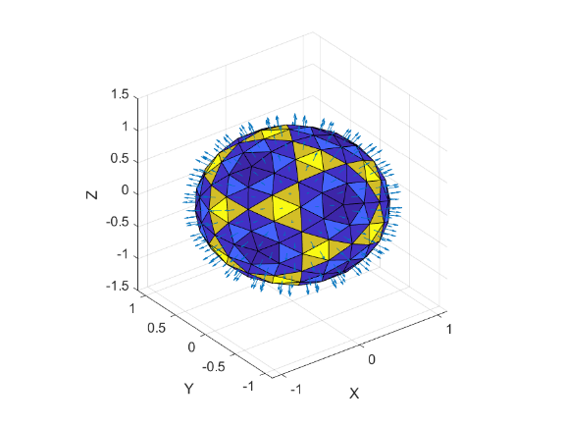 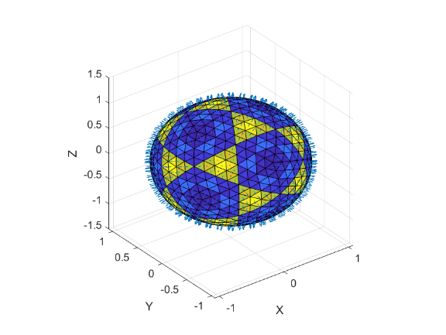 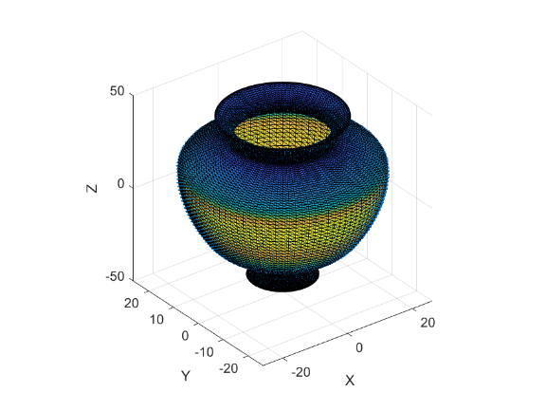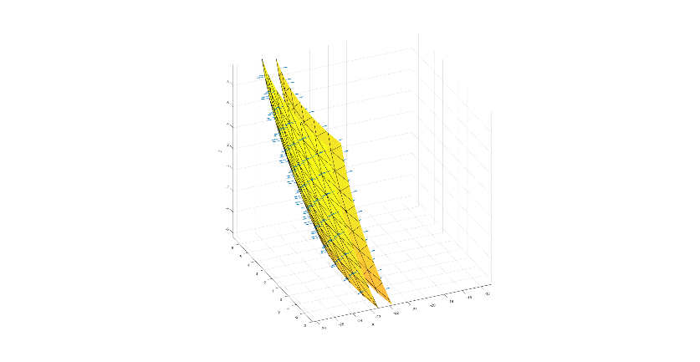 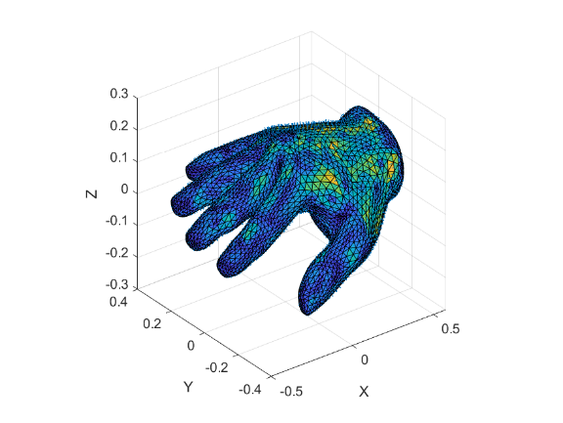 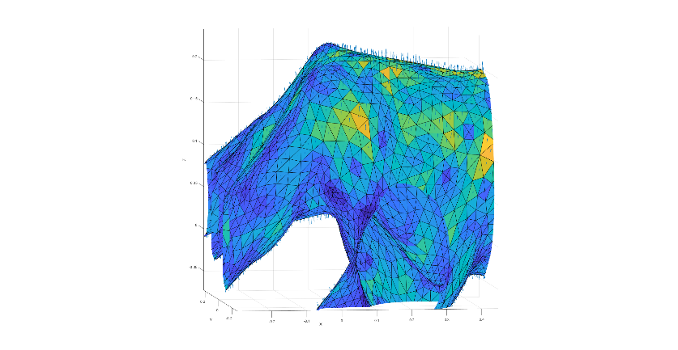

## Q2 – Discrete Differential Operators

### Q2.1 – Discrete Grad

The discrete gradient calculation is implemented here: *calc_grad.m*  
We experimented with several scalar functions on the vertices:

* Pulse: $f\left(v_{i}\right)=1, f\left(V\backslash v_{i}\right)=0$  
  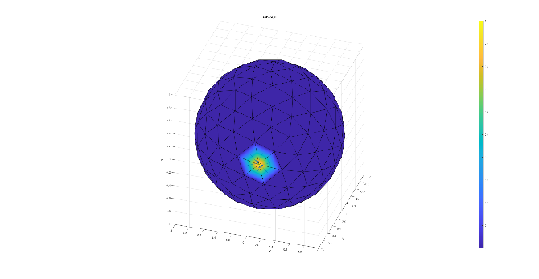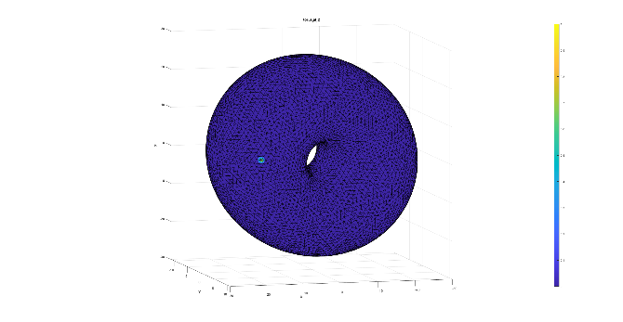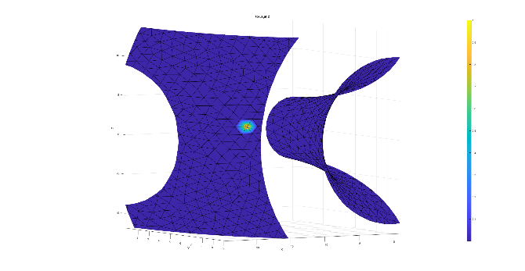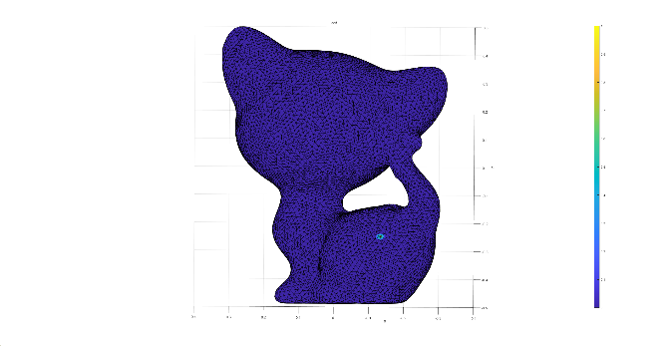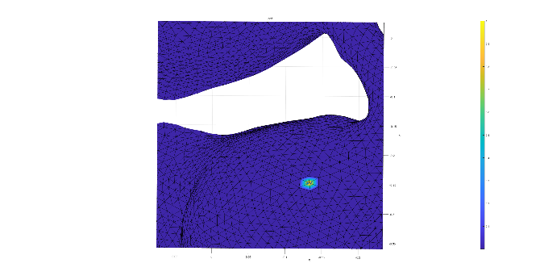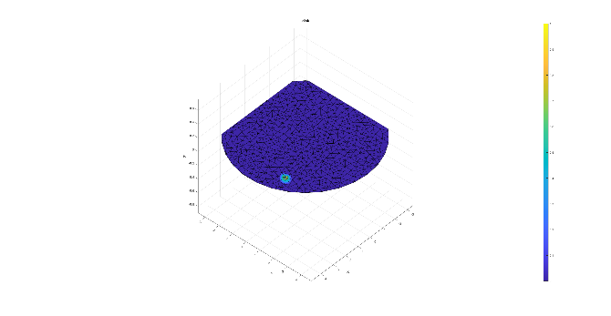
* Barycentric Area:  
  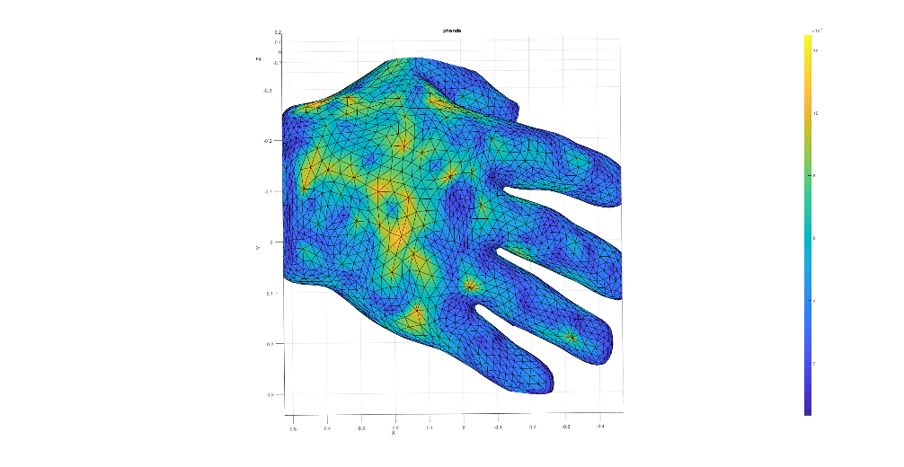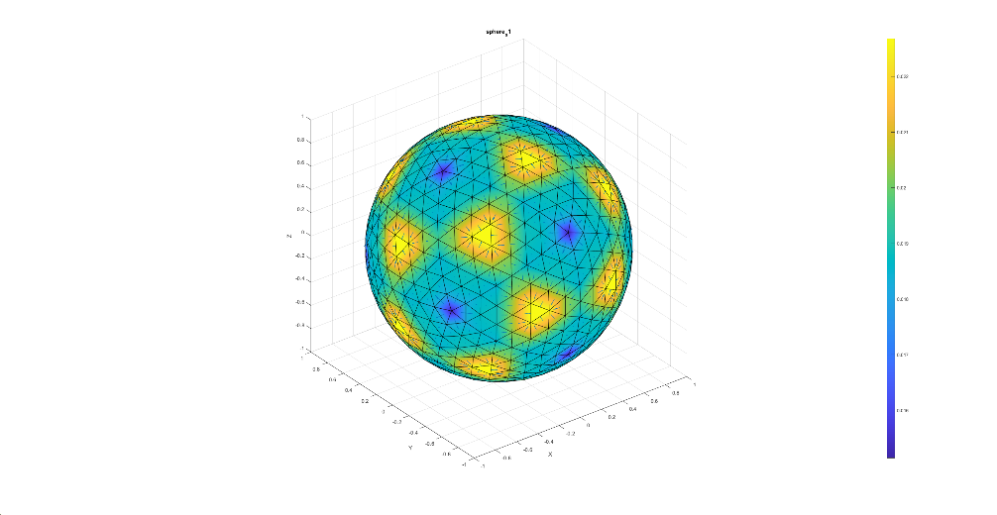
* X coords: $f\left(x,y,z\right)=x$  
  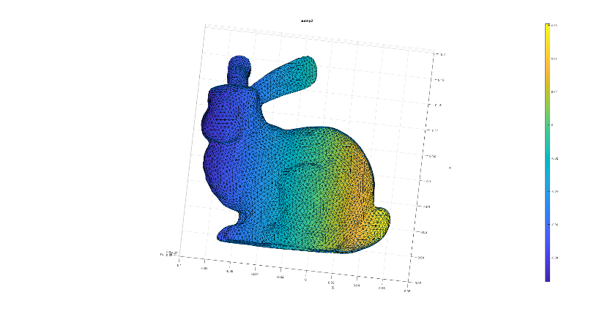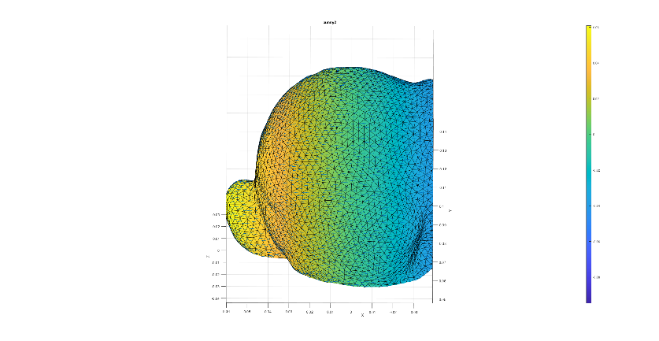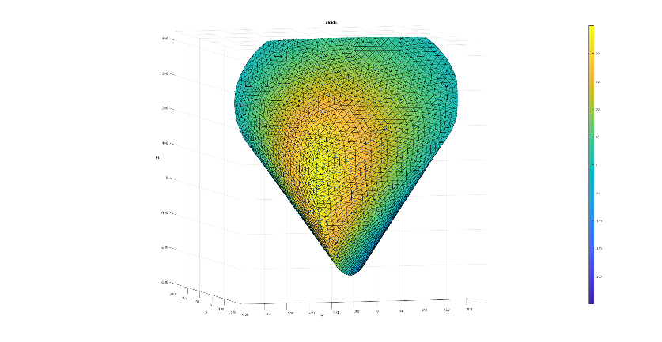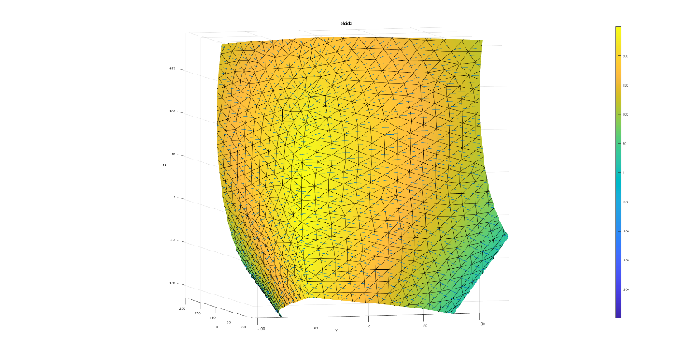

### Q2.2 – Discrete Div

The discrete divergence calculation is implemented here: *calc_div.m*  
We bring here a visualization for the vector function on faces: $f\left(x,y,z\right)=2x$ where $x,y,z$ are each face center.

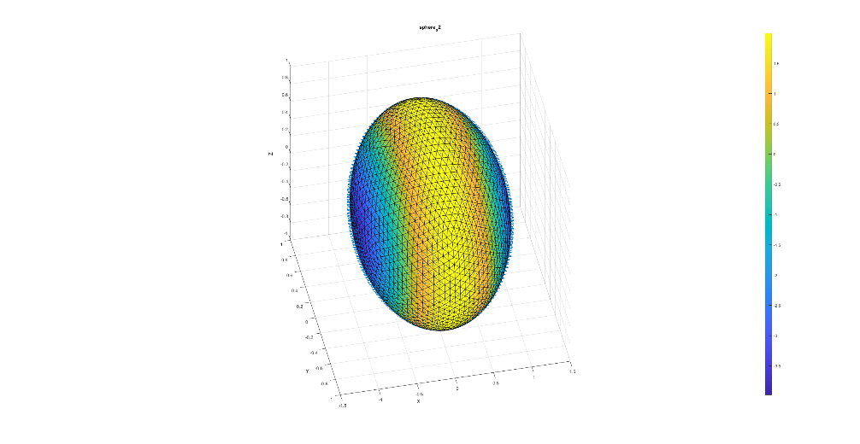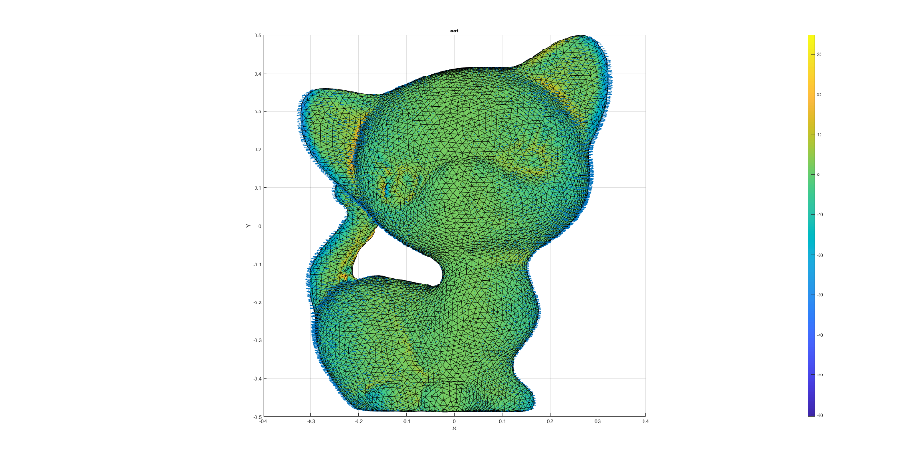

### Q2.3 – Discrete Laplacian

The discrete divergence calculation is implemented here: *calc_lap.m*  
We bring here a visualization for the gradient function on faces for a barycentric vertex area scalar function on vertices.

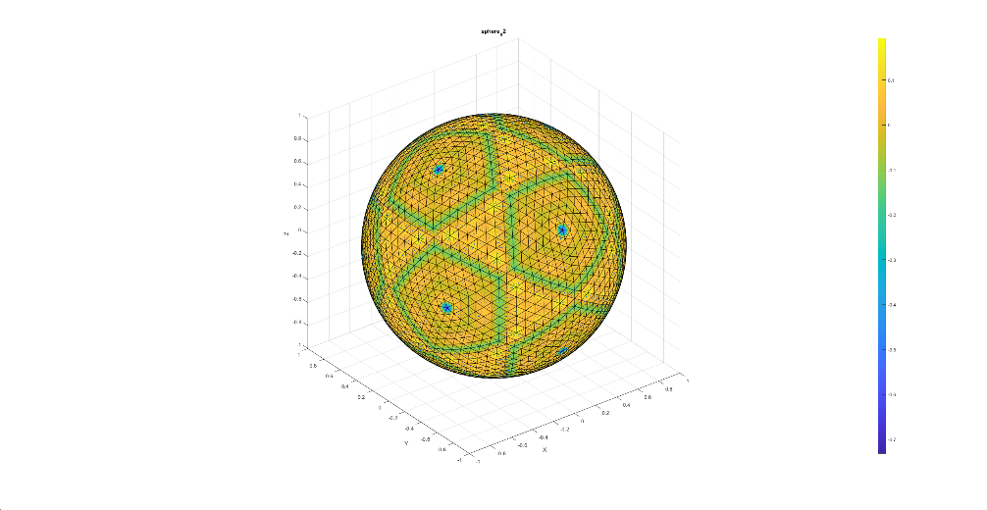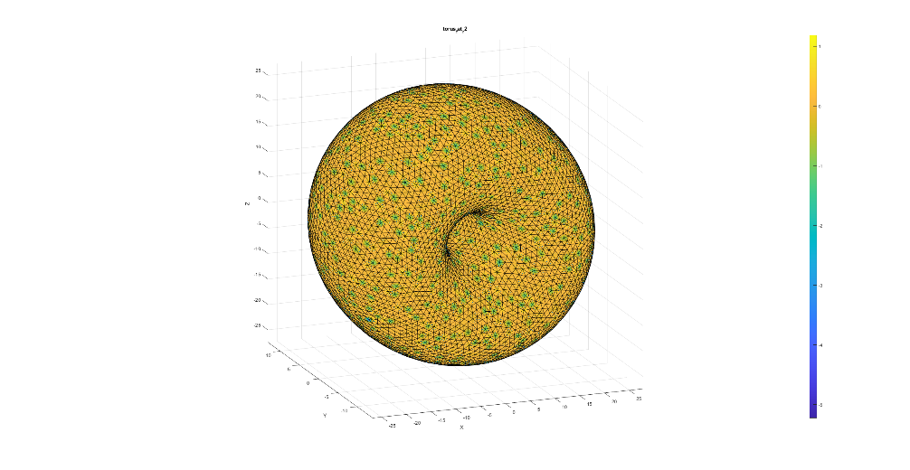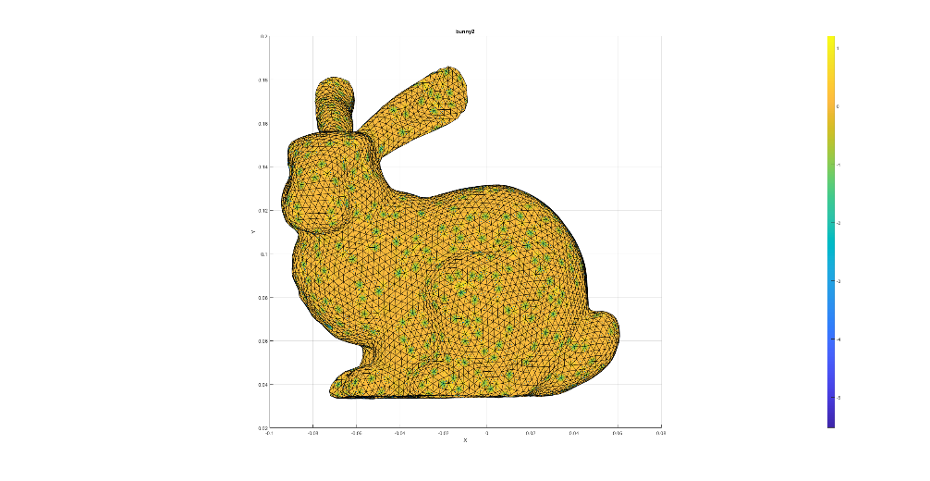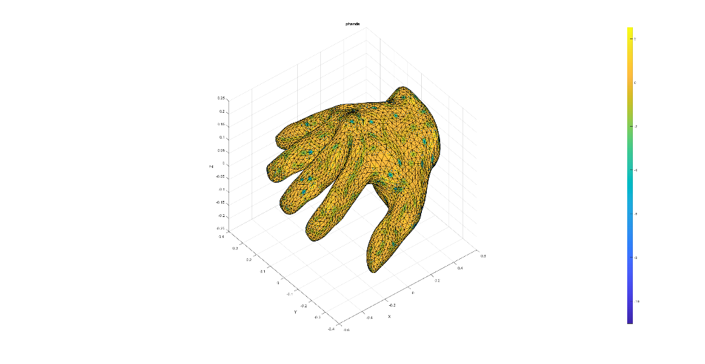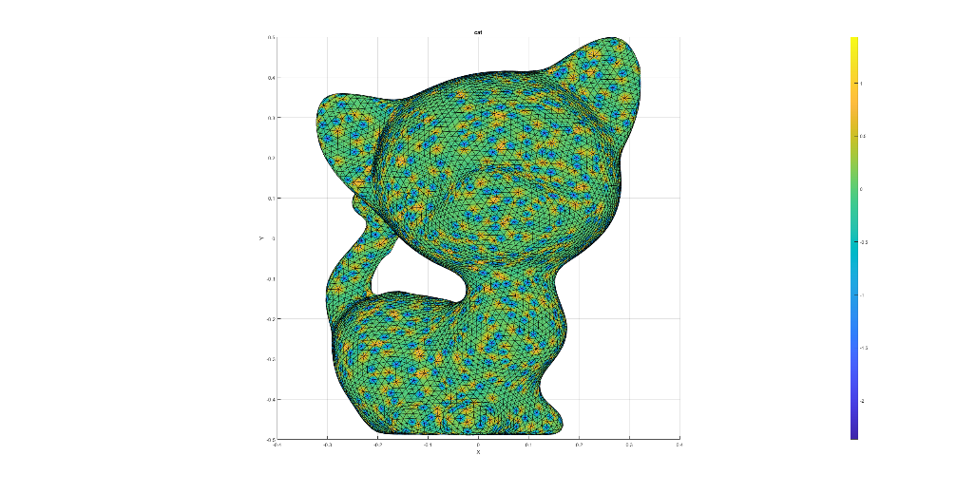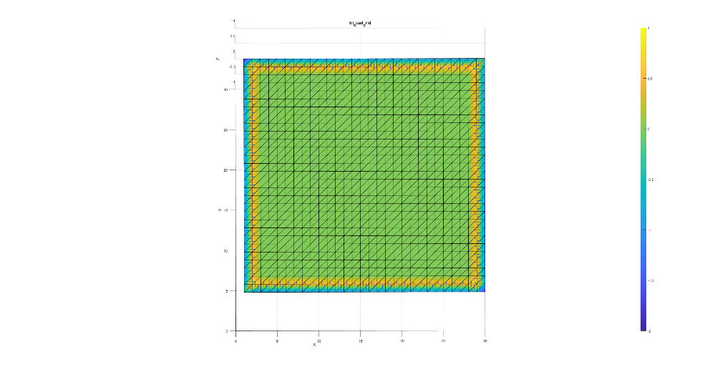

### Q2.4 – Laplace Beltrami

The Laplace Beltrami is calculated in the function: *calc_lap_beltrami.m*  
We run it on various mashes and measure the MSE error vs. the discrete Laplacian operator on the scalar function on vertices: $f\left(v_{i}\right)=2i$.  
  
We noticed that for some reason our algorithm does not work on 2d surfaces (disk, tri_quad_grid). We suspect it is because in the Laplacian Beltrami we assume no boundaries.  
In *calc_lap_beltrami.m* we assume regular edges only, a.k.a, two adjoint faces per edge.

reading hw2_data\bunny2.off ... calc lap ... calc lap beltrami ... done. ||Laplacian(F) - Laplacian-Beltrami(F)||^2 = 0.000039  
reading hw2_data\cat.off ... calc lap ... calc lap beltrami ... done. ||Laplacian(F) - Laplacian-Beltrami(F)||^2 = 0.000004  
reading hw2_data\oloid3.off ... calc lap ... calc lap beltrami ... done. ||Laplacian(F) - Laplacian-Beltrami(F)||^2 = 0.000000  
reading hw2_data\phands.off ... calc lap ... calc lap beltrami ... done. ||Laplacian(F) - Laplacian-Beltrami(F)||^2 = 0.000001  
reading hw2_data\sphere_s0.off ... calc lap ... calc lap beltrami ... done. ||Laplacian(F) - Laplacian-Beltrami(F)||^2 = 0.000000  
reading hw2_data\sphere_s1.off ... calc lap ... calc lap beltrami ... done. ||Laplacian(F) - Laplacian-Beltrami(F)||^2 = 0.000000  
reading hw2_data\sphere_s2.off ... calc lap ... calc lap beltrami ... done. ||Laplacian(F) - Laplacian-Beltrami(F)||^2 = 0.000000  
reading hw2_data\torus_fat_r2.off ... calc lap ... calc lap beltrami ... done. ||Laplacian(F) - Laplacian-Beltrami(F)||^2 = 0.000000  
reading hw2_data\disk.off ... calc lap ... calc lap beltrami ... done. ||Laplacian(F) - Laplacian-Beltrami(F)||^2 = 49661.878919  
reading hw2_data\tri_quad_grid.off ... calc lap ... calc lap beltrami ... done. ||Laplacian(F) - Laplacian-Beltrami(F)||^2 = 944.259498

The following plot assure our assumption regarding the boundaries. For each non-boundary vertex, we get 0 Laplacian, as expected. On the edges, we get something else, and it is different between the Laplace-Beltrami and the Discrete Laplacian.  
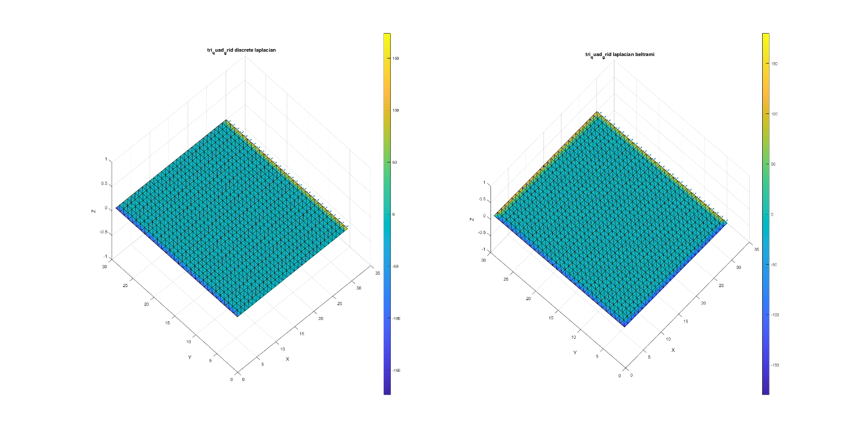

### Q2.5

Each couple of non-boundary vertices, forms two **rights triangles**, with $cot{45}^{o}=1$ in each side (see figure below). Therefore, the weights are zeroed, as so the Laplacian.

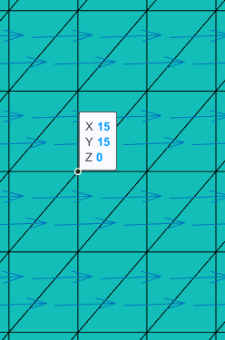

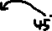

For boundary vertices, the Laplacian-Beltrami formula is not well defined, for example:  
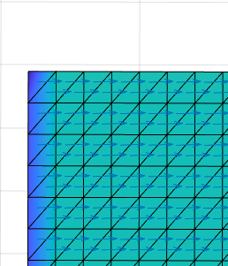

And therefore, we’ve got weird results in section Q2.4 for meshes with boundary.

## Q3 – Vertex Normal

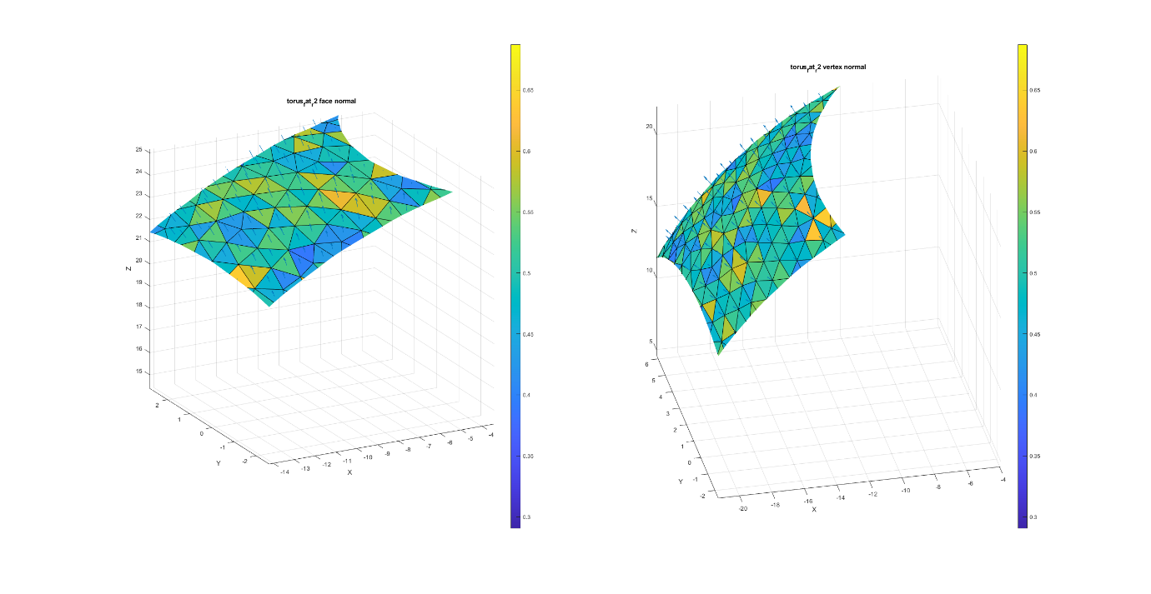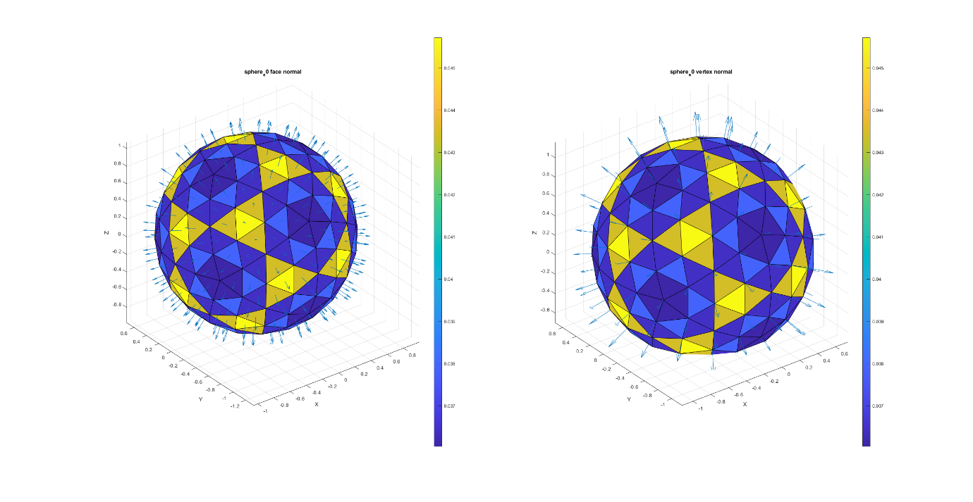

## Q4 – Curvature

### Q4.1 Gauss Curvature

The code is in *calc_gauss_curvature.m*.  
We tested our algorithm by calculating the curvature on a unit sphere, expecting 1 everywhere.  
And indeed, we get almost 1 everywhere:  
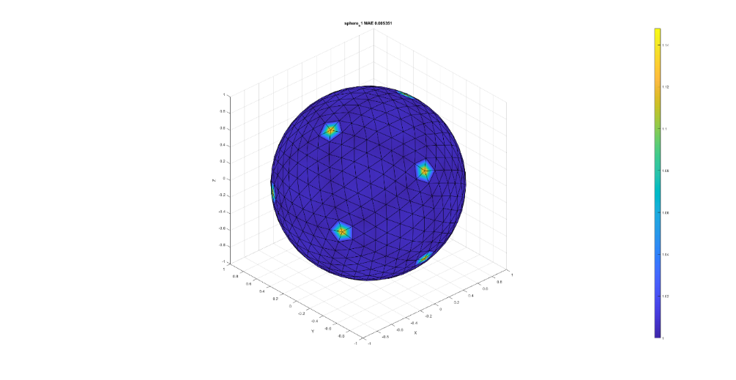

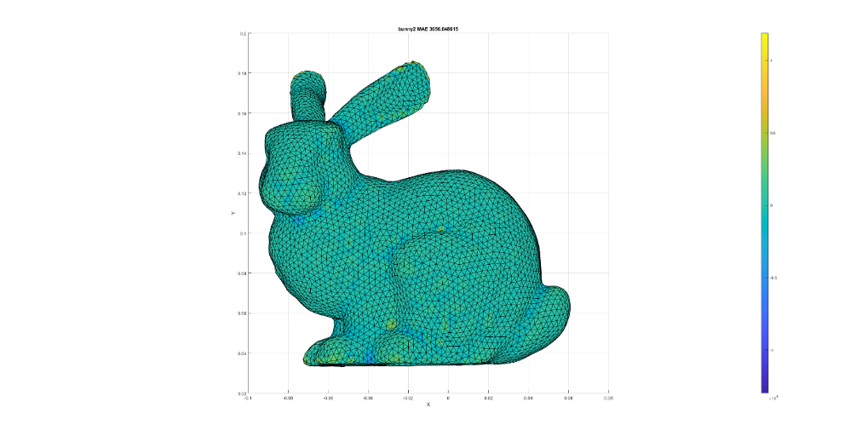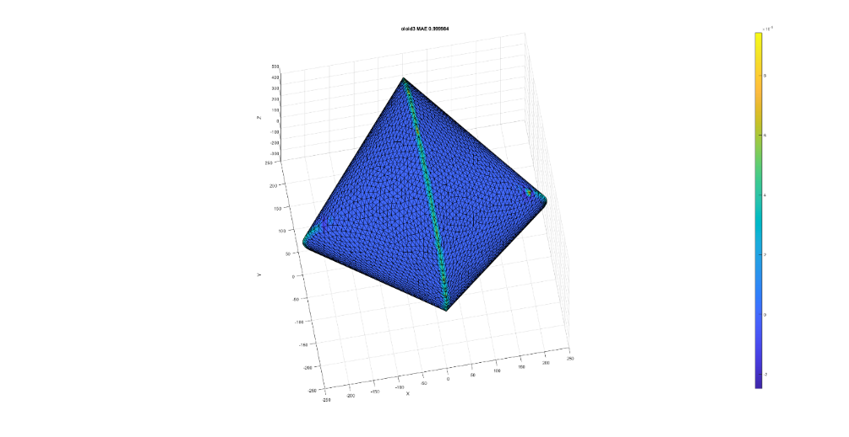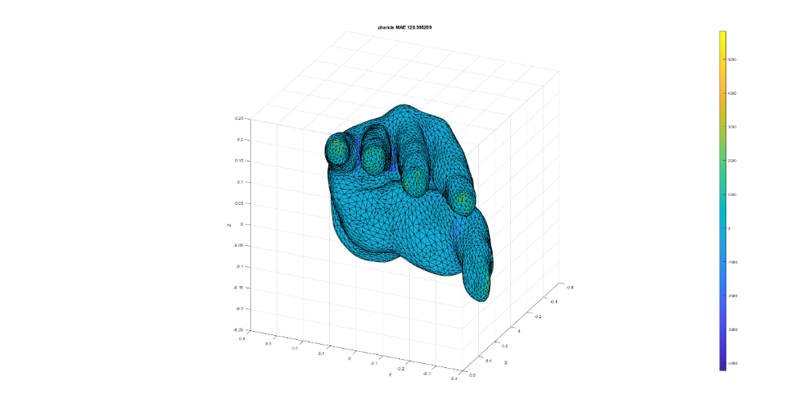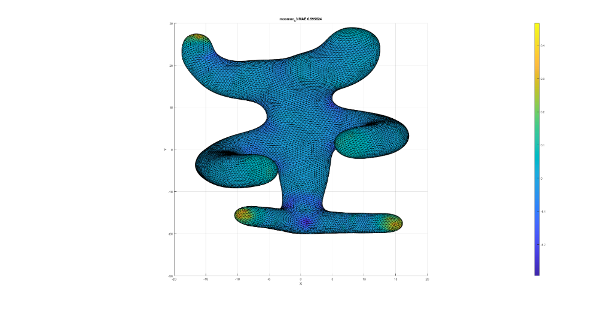

### Q4.2 Mean Curvature

The code is in *calc_mean_curvature.m*.  
We use the Laplacian-Beltrami, but instead of a scalar function we use the coordinates of each vertex. The idea is to measure ‘how fast $x,y,z$ change in each vertex from its neighbors’.  
We then calculate each vertex normal, and inner-producting it with the Laplacian.  
The results on a unit sphere are somewhat weird, not sure why.  
We expect it to be 1 everywhere on a unit sphere, like the Gauss Curvature.  
In a 2nd thought, it might be ok, up to a constant multiplicative scaling factor, since for other meshes, the cat for instance, we get higher values for ‘curvy’ areas, and lower values for ‘flat’ areas.  
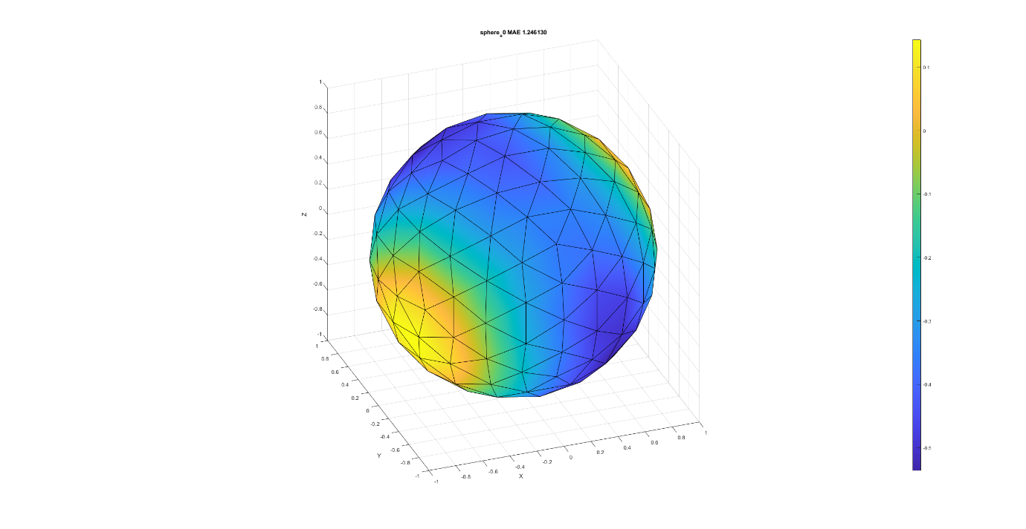  
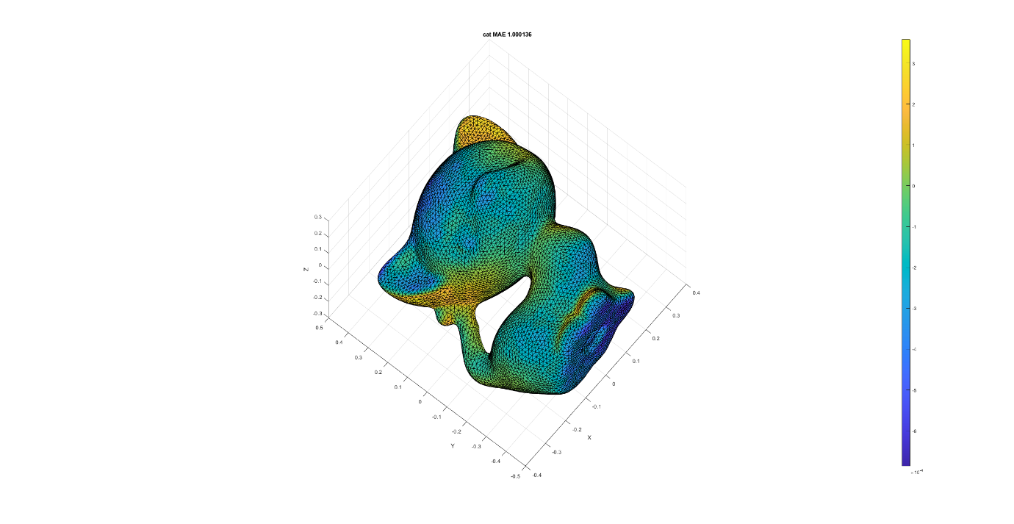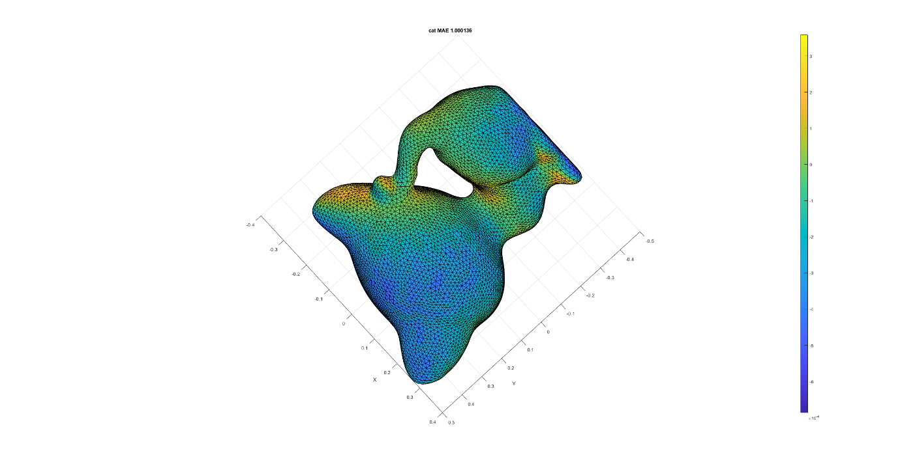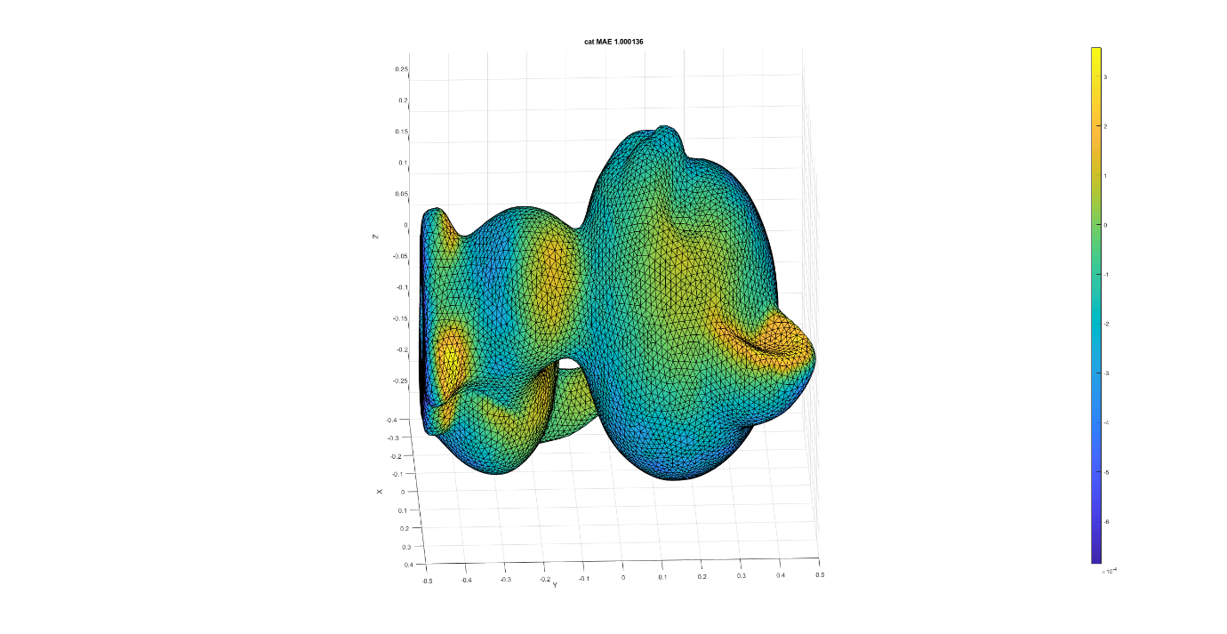

## Q5 – Cotangent Weight Matrix

### Q5.1 – Nullity

The test is implemented in the script: *test_all_cot_weight_mat_nullity.m*.

The Nullity criteria can be explained easily by the Discrete Laplacian definition.  
For any scalar function on vertices $u∈R^{\left|V\right|×1}$, the Discrete Laplacian is given implicitly as: $${\left(Lu\right)}_{i}=\sum_{j}{w_{ij}\left(u_{i}-u_{j}\right)}$$ 
for its i’th cell, where the summation is over the i’th vertex N1 neighborhood. Corollary, $w_{ij}$ is a measure defined on the edge, connected vertex i to vertex j.   
So $Lu≡0$ for any constant vector $u$ such that: $u_{i}=u_{j}∀i,j$.  
Below, one can see that for a const function $f\left(x,y,z\right)=1$, the norm (L2) is zeroed:

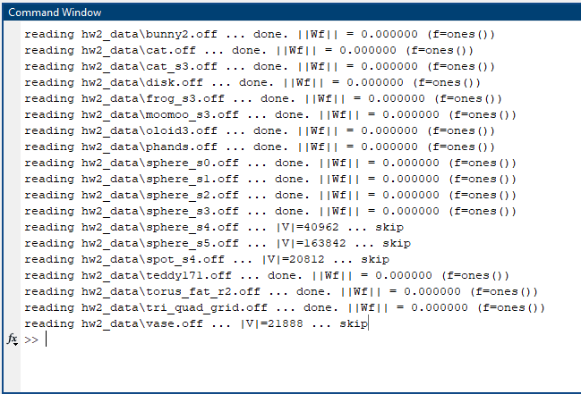

For non-const function, for example: $f\left(v_{i}\right)=i$, the norm is not zeroed:  
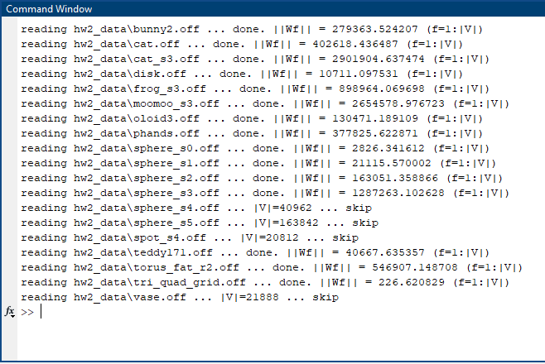

### Q5.2 – Symmetricity

The test is implemented in the script: *test_all_cot_weight_mat_symmetricity.m*.

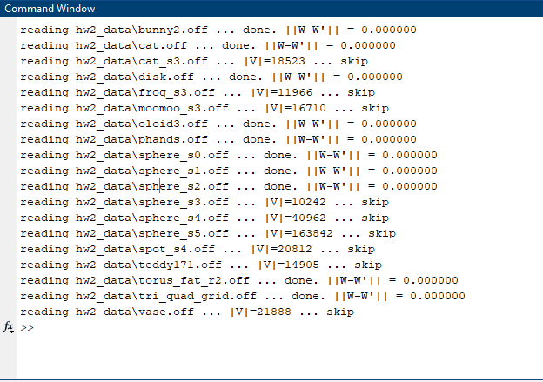

### Q5.3 – Locality

The test is implemented in the script: *test_all_cot_weight_mat_locality.m*.  
Weights are associated to mesh edges (N1 neighborhood), so that $w_{ij}=0$ if i and j do not share an edge in the mesh. So, the number of non-zero elements in the Cotangent Weight Matrix is related to the number of edges in the mesh.  
Cool Note(!): in the previous assignment we saw that the average degree in a closed manifold triangle mesh (simple graph) is 6 (valence). We showed it empirically for the meshes provided.  
We now see that counting the ratio between non-zero elements in the Cotangent Weight Matrix and the number of vertices leads to ~7: each vertex valence + itself.  
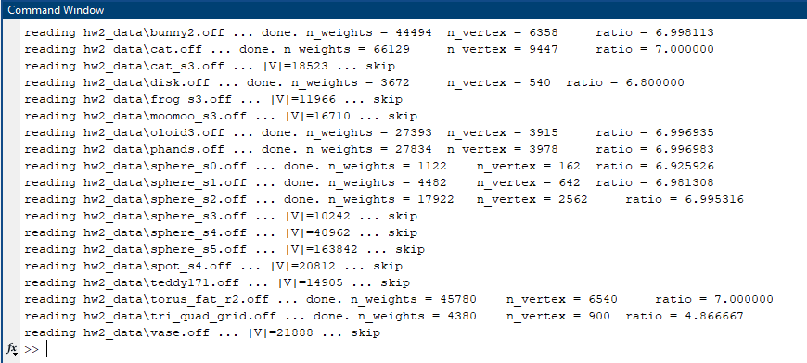

### Q5.4 – non-Positivity

The test is implemented in the script: *test_all_cot_weight_mat_positivity.m*.  
Positive weights are those associates a vertex with itself $(w_{ii})$. The rest are negative.  
for example, for *cat.off*, vertices 1-20:  
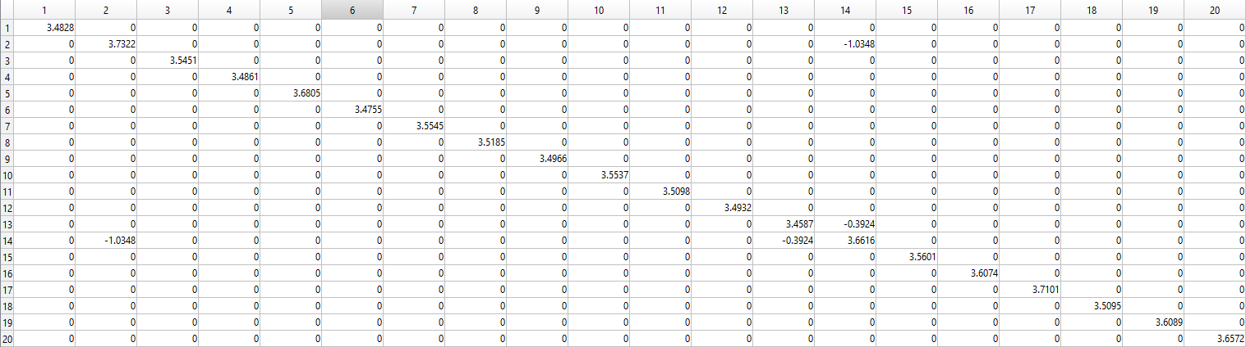  
and for the rest of them:

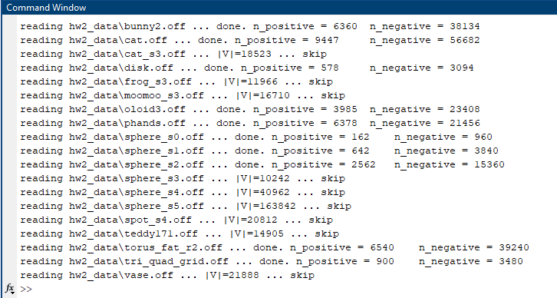

### Q5.5 – PSD

The test is implemented in the script: *test_all_cot_weight_mat_psd.m*.  
A necessary condition for a matrix to be Positive Semi Definite is all eigenvalues are positive.

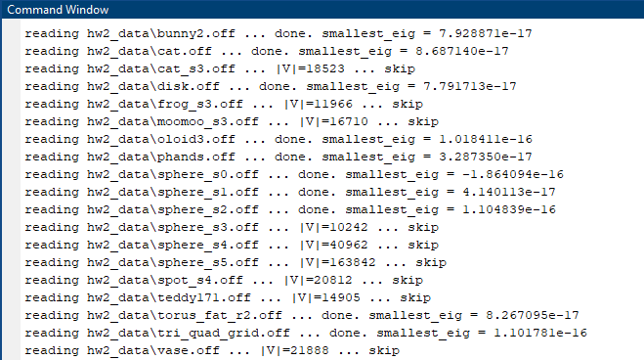

## Q6 – Representation Using Reduced Basis

The test is implemented in the script: *test_all_cot_weight_mat_reduced_basis.m*.  
For each mesh we calculated its reduced basis $B_{i}$, for different $i$, and calculated the projection and back for two functions: pulse function, and the eigenvector corresponds to the largest eigenvalue.  
The results shows that the error decrease with more eigenvectors added to $B_{i}$, for its significance is in reverse-ratio with the number of vertices – for larger vertices, for a given number of eigenvectors, the back-projection error is higher.

### Eigenfunctions correspond to lowest Eigenvalues

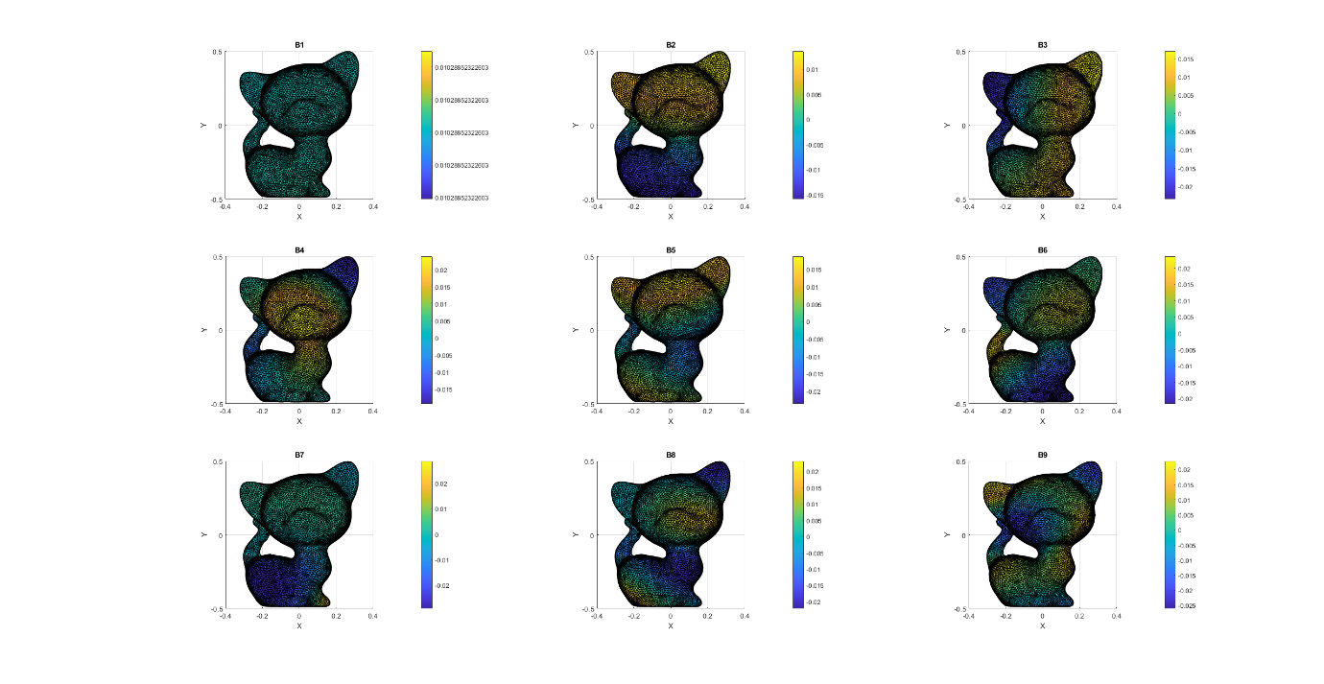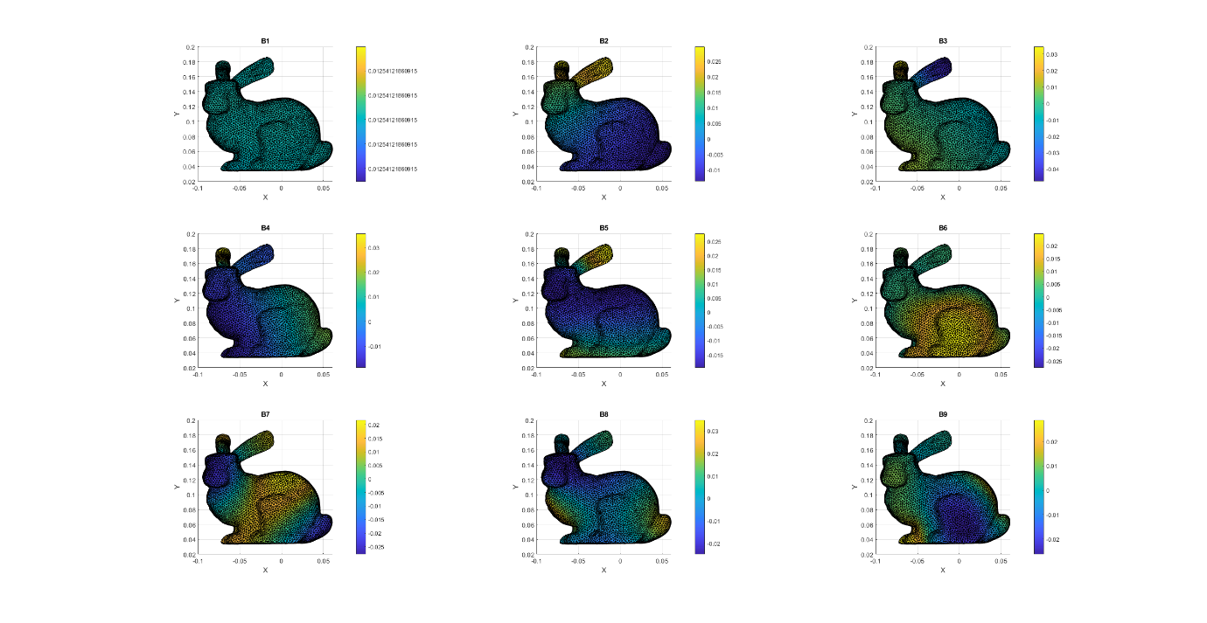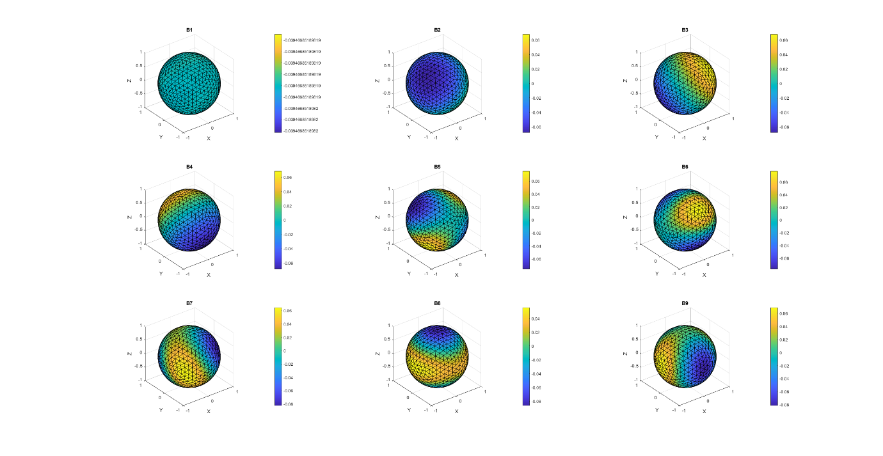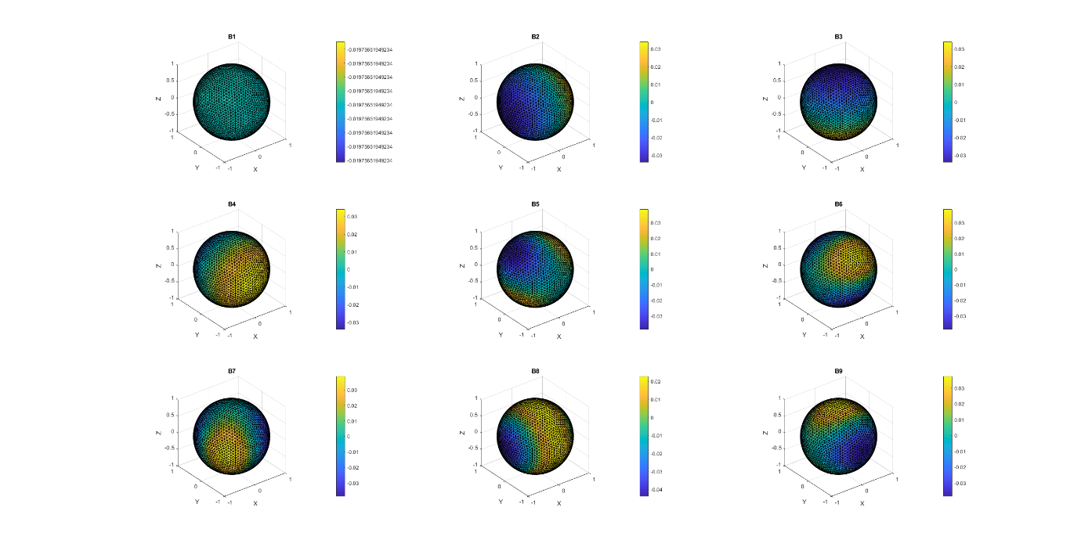

### The pulse function

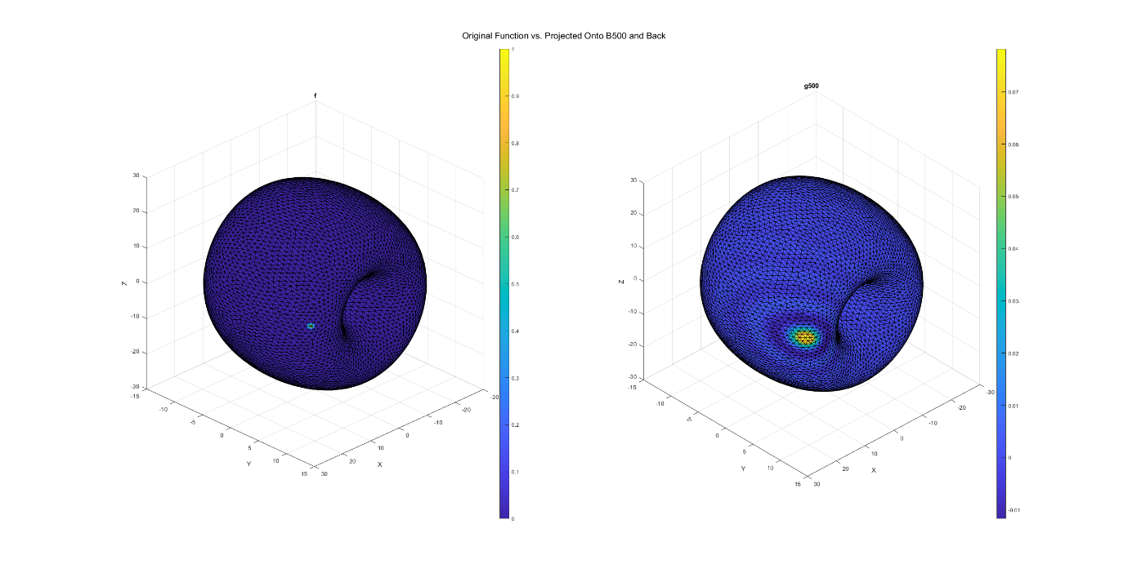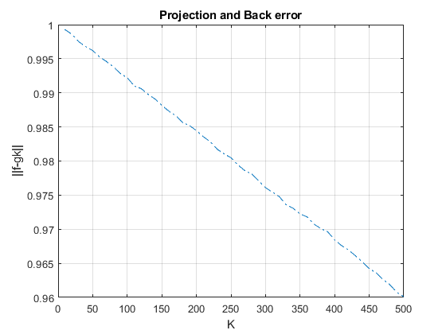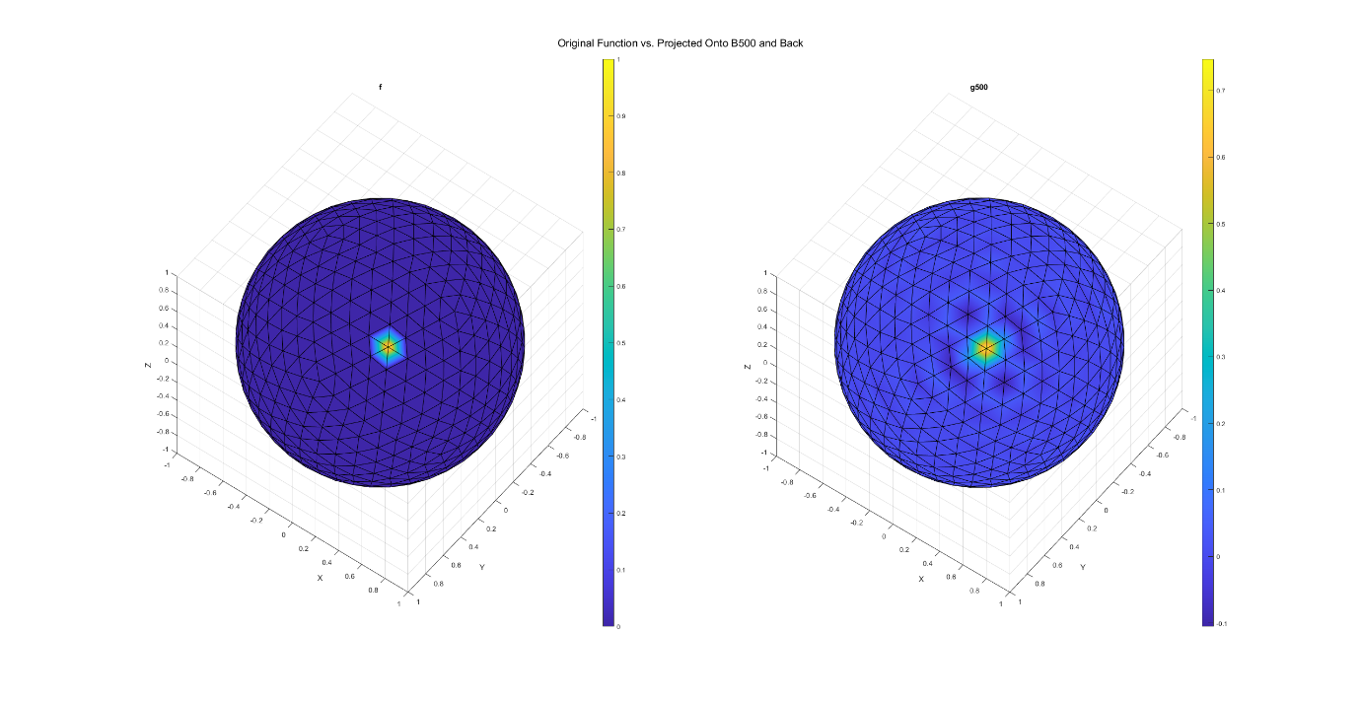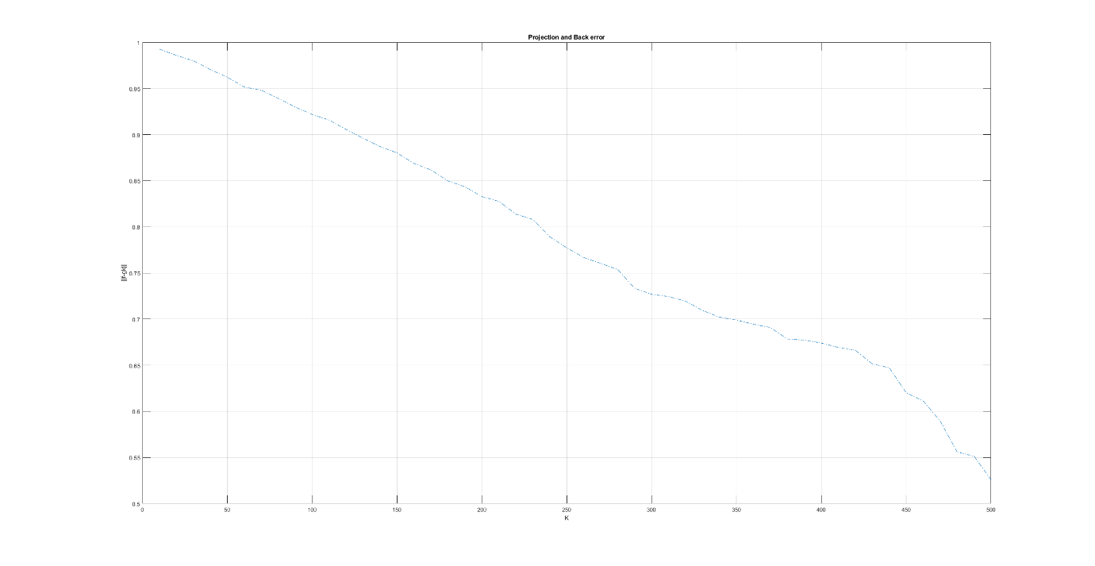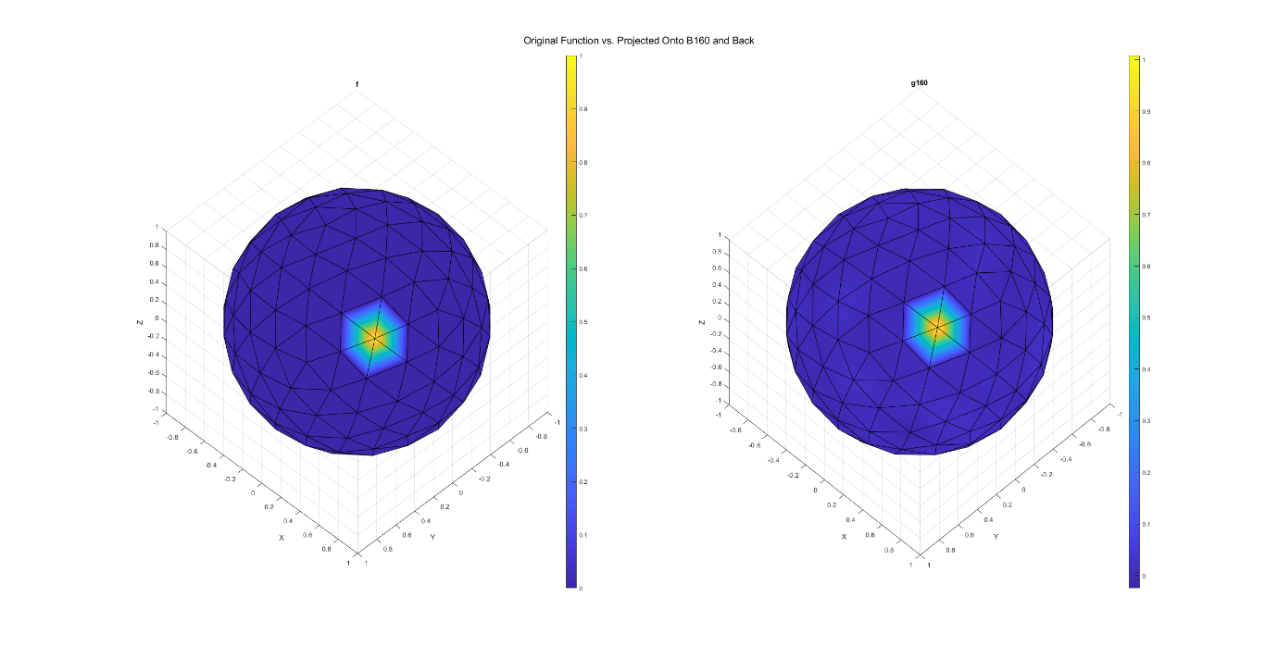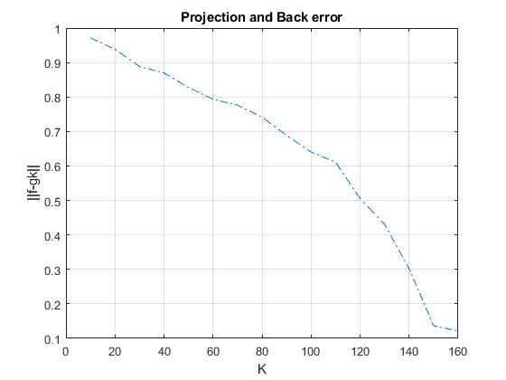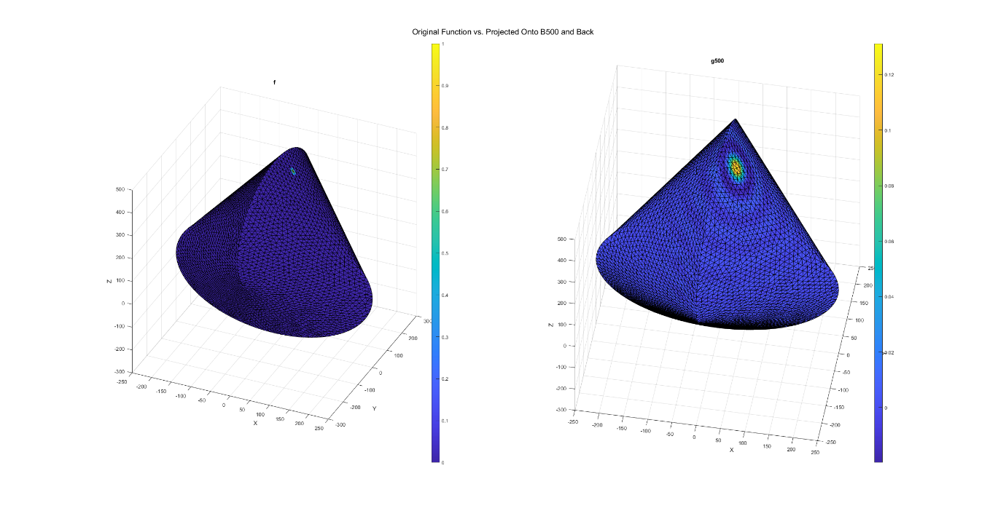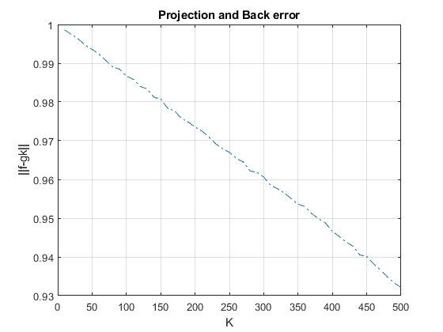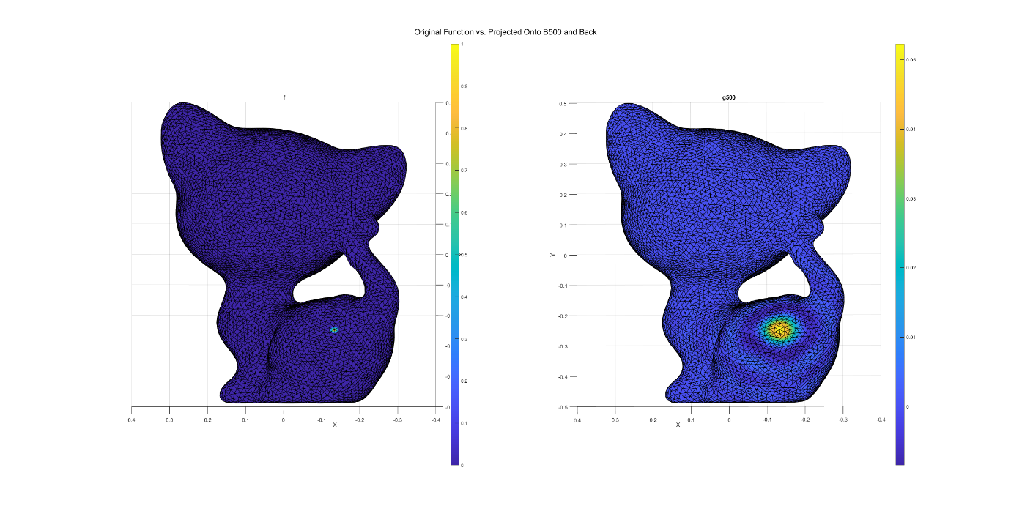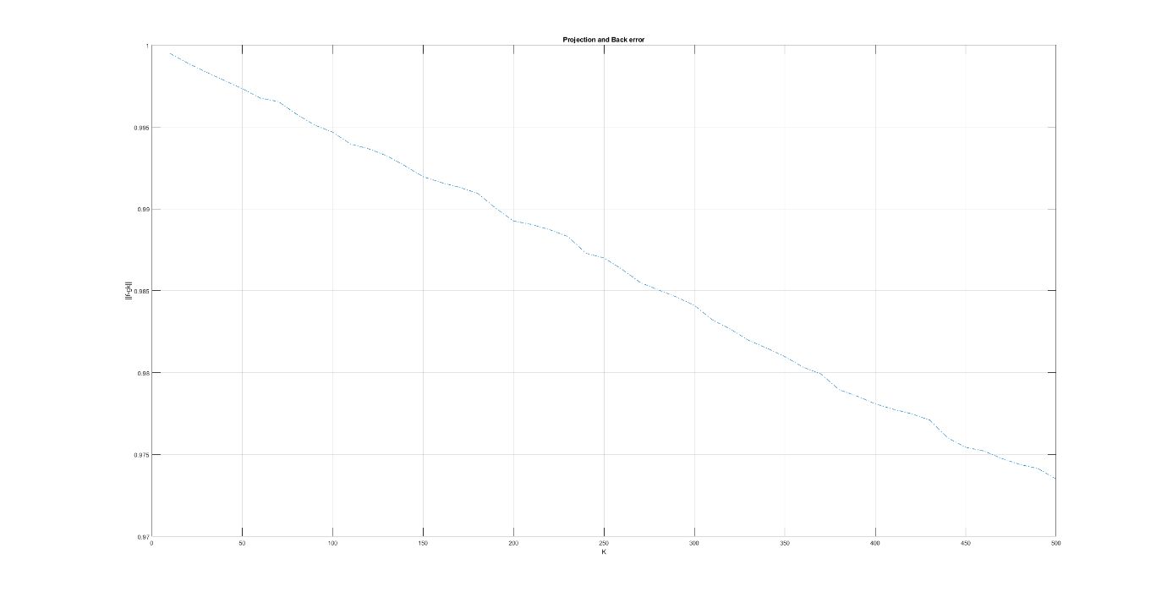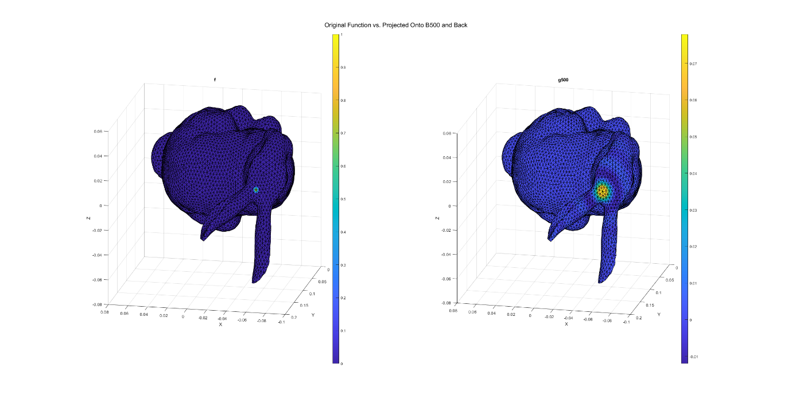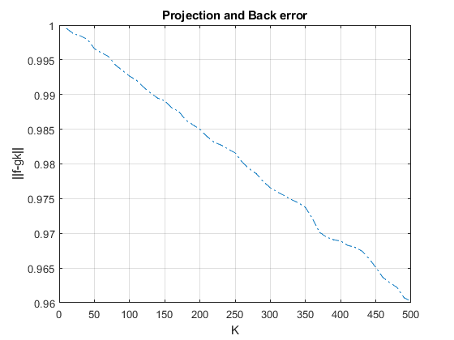

### Largest Eigenvector

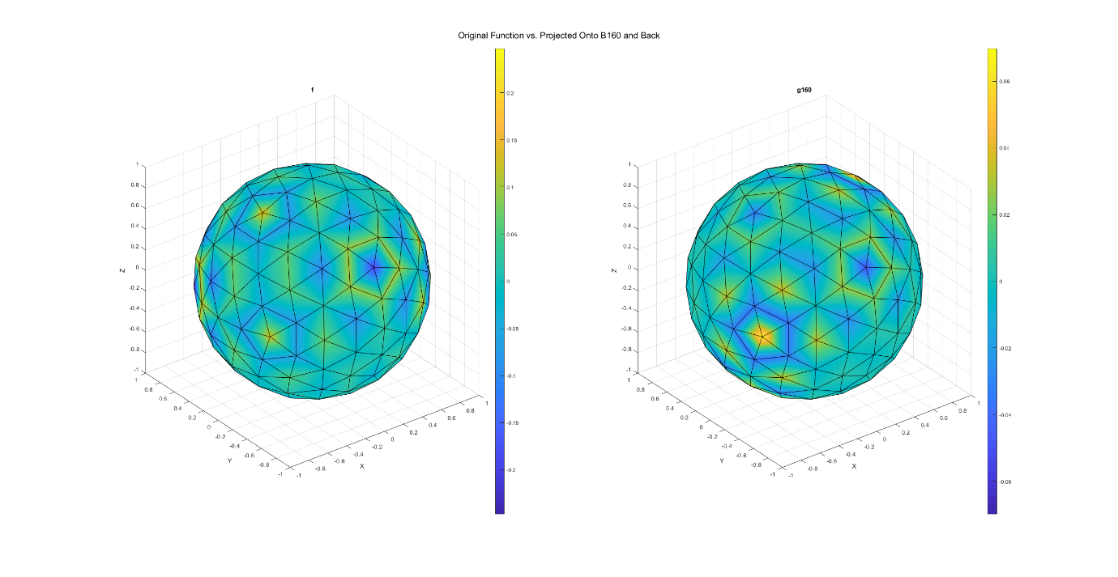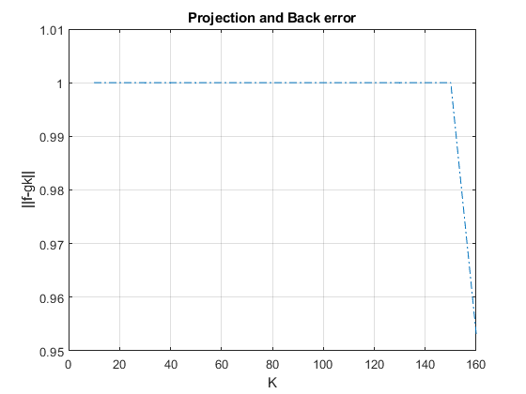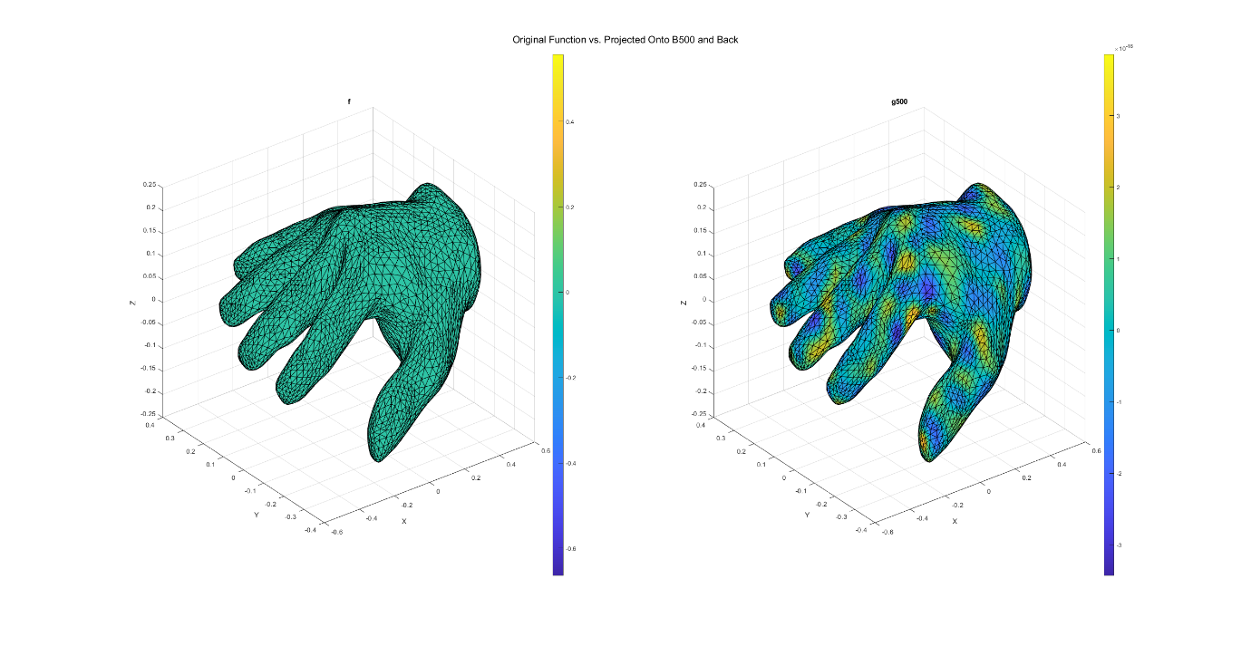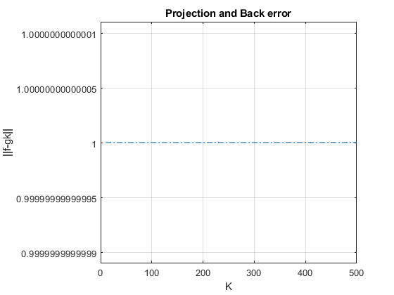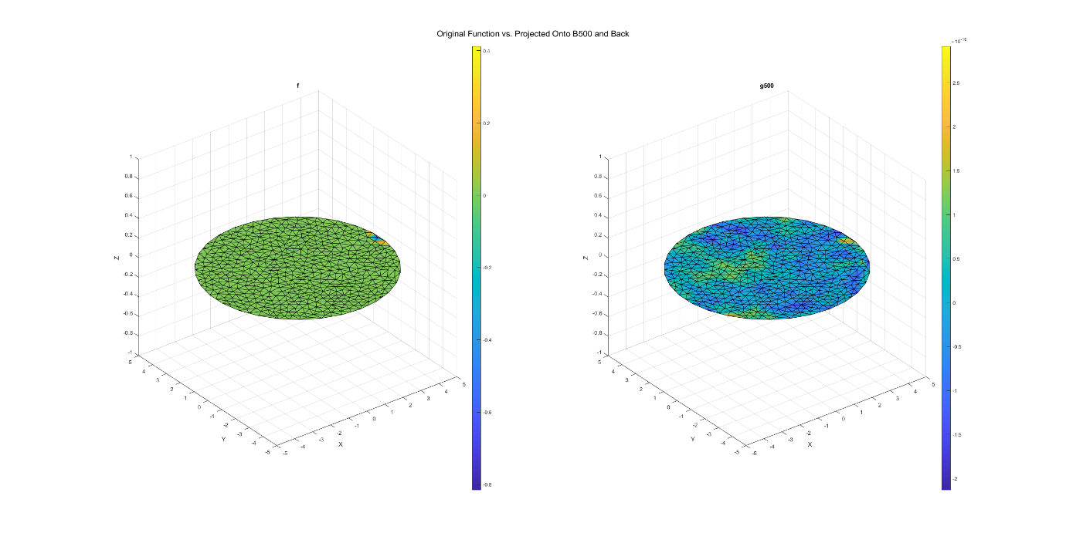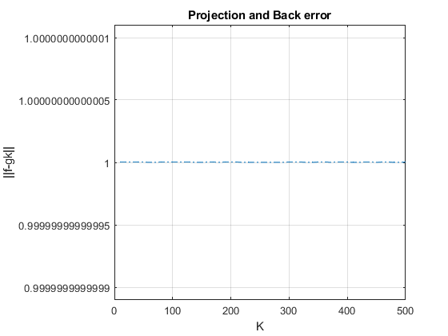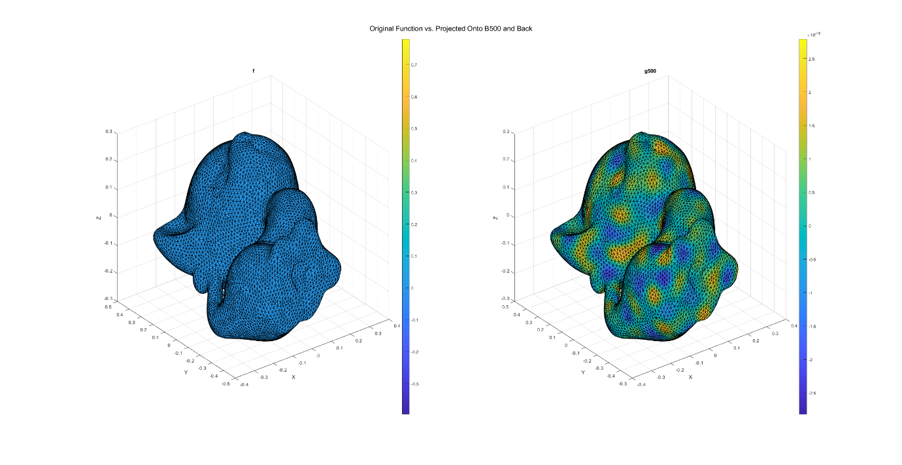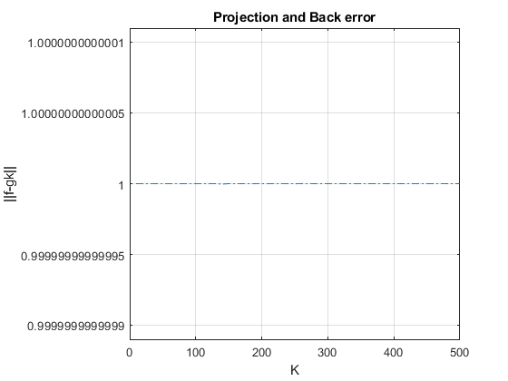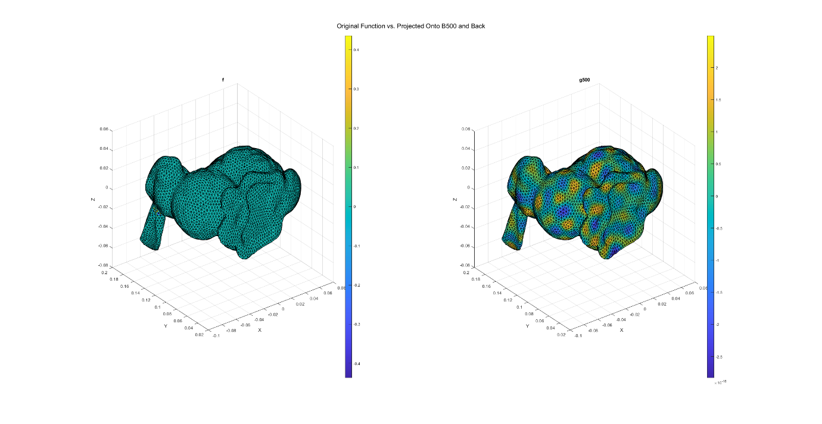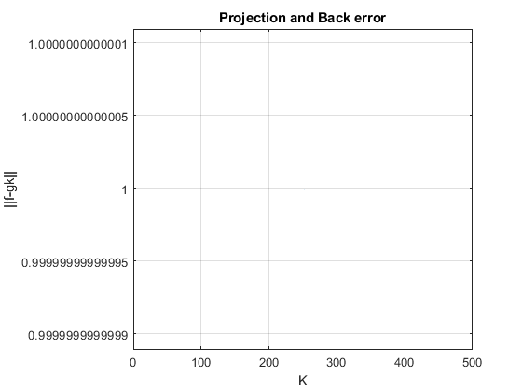

## Q7 – Spherical Harmonics

The test is implemented in the script: *test_all_cot_weight_mat_spherical_harmonics_reduced_basis.m*.

First, we calculated $B_{1}-B_{9}$, eigenvectors correspond to first-to-ninth lowest eigenvalues.  
Then we translated each cartesian vertex on unit sphere mesh coordinate to spherical coordinate, ignoring the r component. Also, for this purpose, we ignored the elevation component ($ϕ$), since we visualize only the real part of Laplace Equation solutions, and $ϕ$ appears only in the imaginary part: $$Y_{l}^{m}\left(θ,ϕ\right)=\sqrt{\frac{2l+1}{4π}\frac{\left(l-m\right)!}{\left(l+m\right)!} }P_{l}^{m}\left(\cos\left(θ\right)\right)e^{imϕ}$$ 
where: $P_{l}^{m}$ is Legendre Polynomial.  
Using the new coordinate system, we calculate spherical harmonic 1-9 ().  
1) Each spherical harmonic is a solution to Laplace equation ($∇^{2}f=0$), means, $f$ that satisfies the equation.

2) are eigenvectors of $W$ which is a discrete operator form approximation to $∇^{2}$, means, they are $f$ such that: $Wf=λf→∇^{2}f=λf$.

From 1) & 2) stems that the spherical harmonics should be like the eigenvectors up to constant scaling and rotation. The following plots demonstrate this idea.   
We hypothesize that the spherical harmonic would be part of $W$ Null Space but didn’t see how it is connected to $B_{i}$.

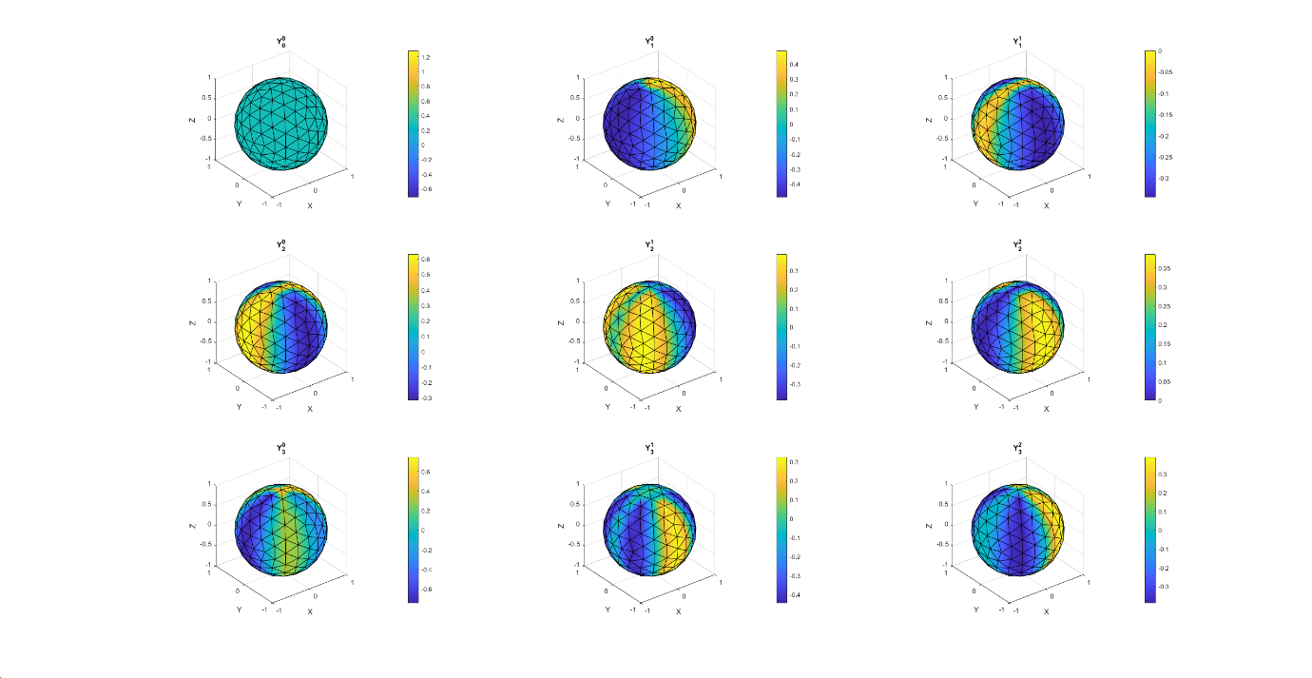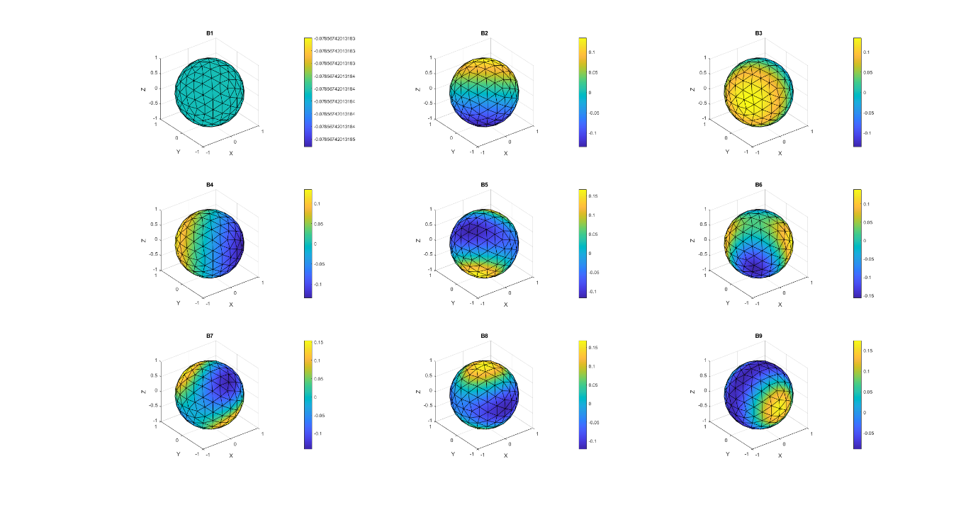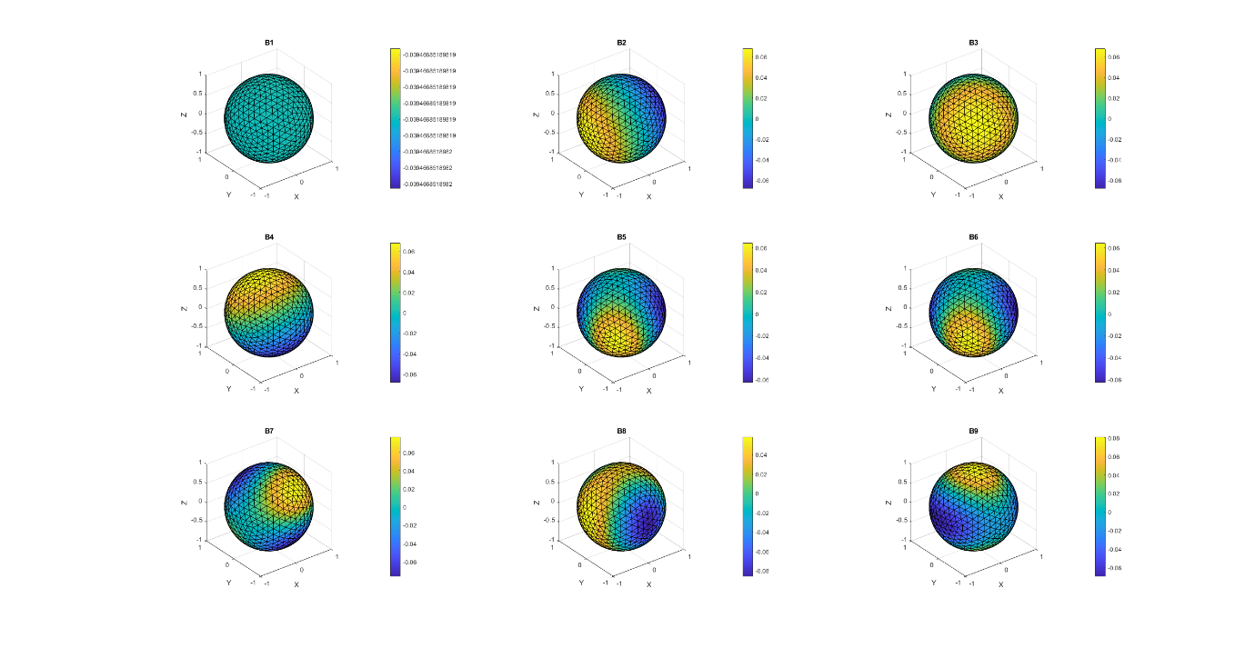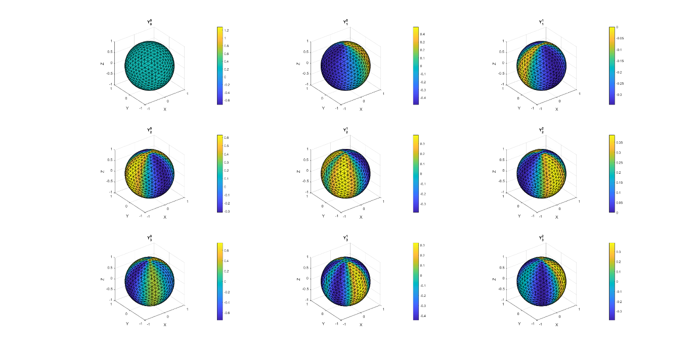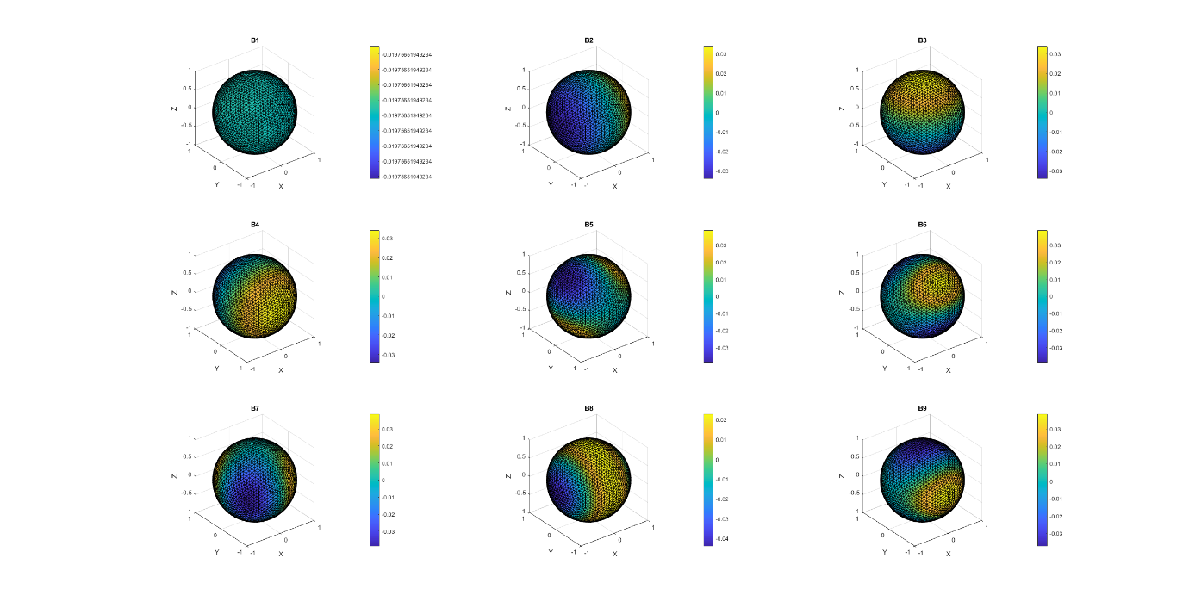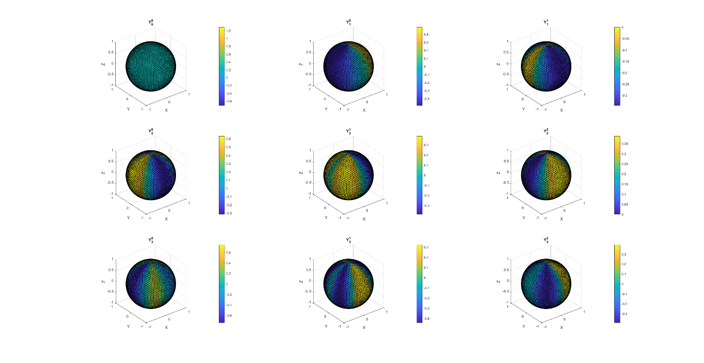

## 

ds